“PATRICK BROWN EVENTING CLINIC”
SATURDAY 7th & SUNDAY 8th APRIL 2018
Booking Form
ENQUIRIES: Dave 082 554 0809 & Belinda 082 909 1121
*This clinic is limited to 30 horse/rider combinations*
Name and Surname : _______________________________________________
Email Address: _______________________________________________
Contact Number : _______________________________________________

Times | Heights |  | Saturday 7th April |  | 1.5 hour lesson horse/rider combination
07.30-09.00
09.00-10.30
10.30-12.00
12.00-13.00 | LUNCH
13.00-14.30
14.30-16.00
Times | Heights | Sunday 8th April |  | 1.5 hour lesson horse / rider combination
07.30-09.00
09.00-10.30
10.30-12.00
12.00-13.00 | LUNCH
13.00-14.30
14.30-16.00
 |  |  |  | 3 Hour Lesson Fee |  | R750
The clinic is run over 2 days, building on from day 1 to day 2 culminating in completing a track/set of jumps – one day cannot be done in isolation

In addition:-
- R165.00 Ground Levy to Shongweni Club
- R300.00 Temp membership for non-Shongweni Club members
- For Stabling please speak to Shana at Shongweni Club 031-768 1251

Direct Deposits to :
DSC Members pay : R915.00
Non-DSC Members pay : R1,215.00
Bank: Absa Bank, Account name: Belinda Jelf Trading, Branch: Hillcrest, KZN, Branch code: 8197, Account number: 409 243 1415Places on courses are secured only upon receipt of a completed registration form as well as proof ofpayment by email to belinda.jelf2014@gmail.com

Indemnity:
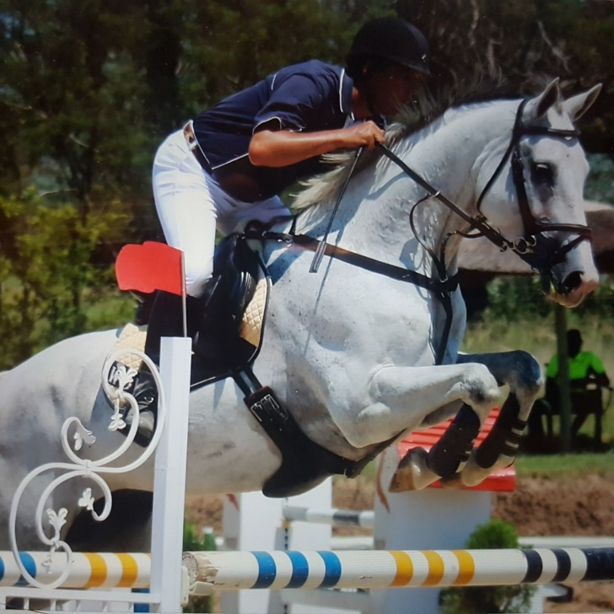
All persons participating do so at their own risk and will have no claim against Durban Shongweni Club nor organiser of the Clinic, including any officials, employees or representatives for anydamage or loss of property or death or injury of persons suffered during or in connection with thisevent from any cause whatsoever. No minor may participate without the permission of his/herguardian, who indemnifies Eventing SA and KZN Eventing (including all such other persons andbodies) against any such claims by such minors.No horses may be brought onto the property with any contagious diseases and/or without their vaccinations being up to date.
Full body protectors, crashers & tack/saddlery must be worn at all times.

Signed: _________________________________

