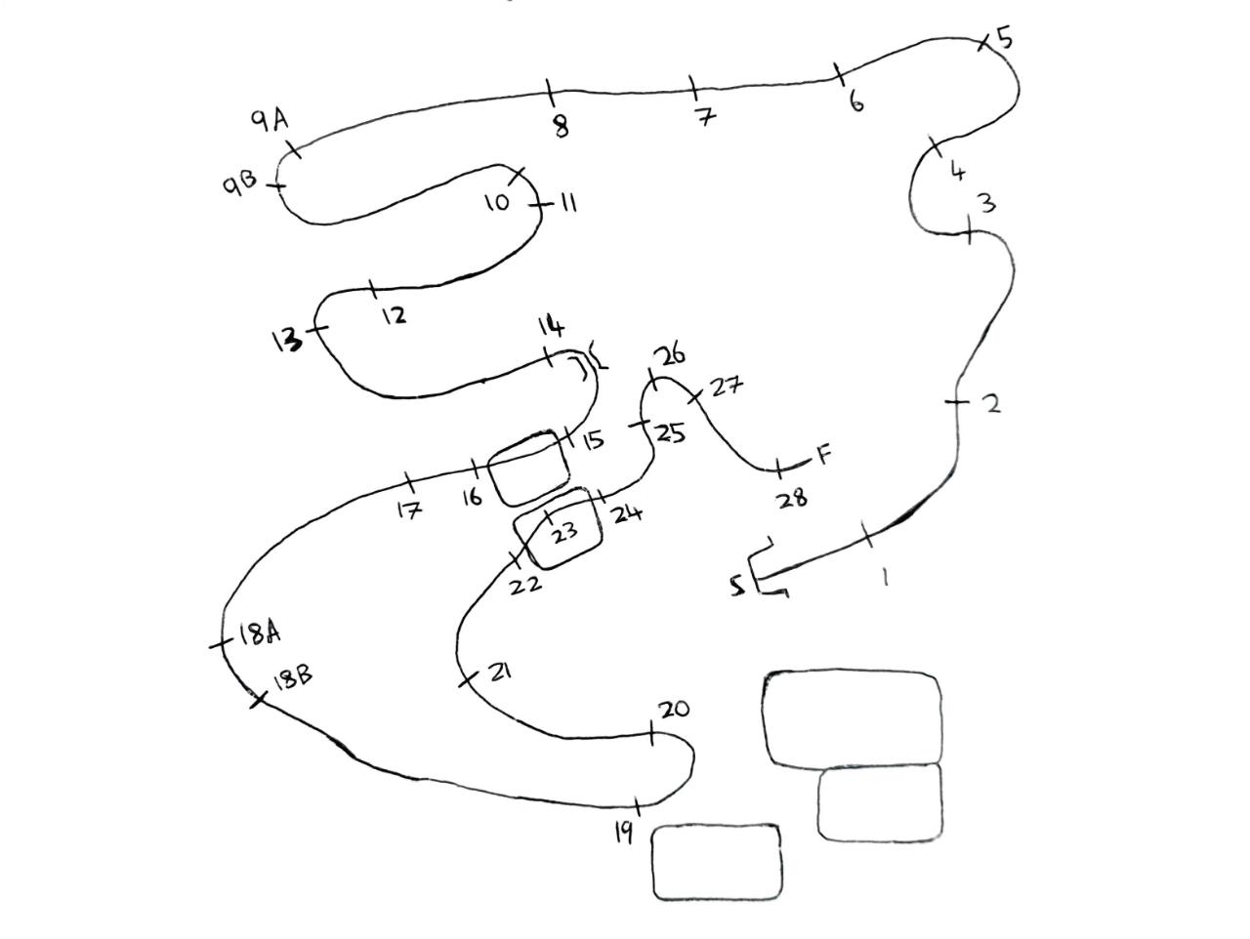

1. The fun has begun 6. Ditch 10. WOW 15. Fish 19. Triple Bar 24. Box
2. Slanter 7. Boxer 11. Trakehner 16 Corner 20. A Frame 25. Log in
3. Oxer 8. Roll top 12. Upright 17 Fish 21. House 26. Upright
4. House 9a. Roll top 13. Table 18a. Roll top 22. Log in Water 27. Log out
5. Trakehner 9b. Corner 14. Brushes 18b. Roll top 23. Crocodile 28. Lucky last
6. .